**Session-19 Assignment**

**Name :-** Aryan Dilipbhai Langhanoja

**Enroll No :-** 92200133030

**AIM**: To understand basics of closed loop operational amplifier configurations like inverting, non-inverting and differential configurations.

**Objective:**

1. To understand the limitations of open loop configurations.
2. To understand closed loop configurations like non-inverting, inverting and differential configuration.
3. To analyze the effect of how to control gain and bandwidth of various closed loop configurations along with design equations using external components.

**Apparatus:**

1. DC power Supply
2. OPAMP uA741.
3. Resistor

**Task-1- Limitations of Open loop configurations**

1. The configuration in which output depends on input,but output has no effect on the input is called open loop configuration.
2. No Feed back from output to input is used in such configuration.
3. The op-amp works as high gain amplifier.
4. The op-amp can be used in three modes in open loop configuration they are

(1) Differential amplifier

(2) Inverting amplifier

(3) non-Inverting

**Task-2- Types of Feedback Circuits**

1. Positive feedback
2. Negative feedback

**Task-3: Closed loop Inverting amplifier**

**Circuit diagram:**

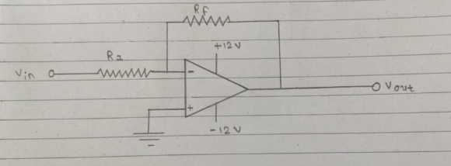

**Task-4: Closed loop non-inverting amplifier**

**Circuit diagram:**

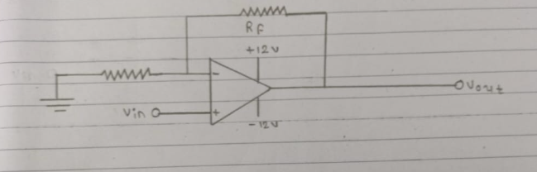

**Task-5: Closed loop Differential amplifier**

**Circuit diagram:**

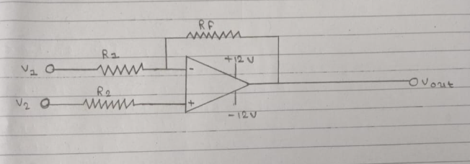

**Task-6: Equations for Closed loop Gain for OPAMP Configurations**

Inverting configuration:- Voutput = (-Rf/R1)Vinput

Non-inverting Configuration:- Voutput = (1 + Rf/R2 )Vinput

Differential Configuration: Voutput = Vnon-inverting – Vinverting

(1 + Rf/R2 )Vinput + (Rf/R1)Vinput

Vinput ( 1 + Rf ( 1/R1 + 1/R2) )

**Task-7: Frequency Responses of Inverting Amplifier using AC Analysis**

**Here you need to plot a graph of Voltage gain Vs. Frequency. Keep input signal sine wave of 1V Peak value. Set gain of 10 and observe output for various frequencies. (10Hz to 100KHz) (Take minimum 20 readings)**

|  |  |
| --- | --- |
| **Frequency** | **Voltage Gain** |
| 100 | 3.431 mV |
| 1KHz | 3.431 mV |
| 2KHz | 3.431 mV |
| 3KHz | 3.431 mV |
| 4KHz | 3.431 mV |
| 5KHz | 3.431 mV |
| 6KHz | 3.431 mV |
| 7KHz | 3.431 mV |
| 8KHz | 3.431 mV |
| 9KHz | 3.431 mV |
| 10KHz | 3.431 mV |
| 20KHz | 3.431 mV |
| 30KHz | 3.431 mV |
| 40KHz | 3.431 mV |
| 50KHz | 3.431 mV |
| 60KHz | 3.431 mV |
| 70KHz | 3.431 mV |
| 80KHz | 3.431 mV |
| 90KHz | 3.431 mV |
| 100KHz | 3.431 mV |

**Conclusion:**